Analysis of ABoVE Synthetic Aperture Radar (SAR) soil sensing techniques with concurrent in-situ data at field sites on the Barrow and Seward Peninsulas

**Abstract:**

Researchers in the DOE Office of Science Next-Generation Ecosystem Experiments, NGEE-Arctic, and NASA Arctic Boreal Vulnerability Experiment (ABoVE) projects are collaborating on the development of regional soil moisture data products to improve and assess Earth System Models. Here we present our analysis of in-situ measurements of soil moisture, soil physical properties,and thaw depth collected during the summer of 2017 coincident with NASA ABoVE airborne overflights of L and P-band SAR instruments. New analyses show that the spatial distribution of soil moisture and active layer depth derived from Airborne SAR- using a two-layer dielectric structure (Chen et al. 2019)- differ based on local geomorphology, topography, climate and vegetation properties across a range of field sites and settings near Utqiaġvik, AK and Nome, AK. In Utqiaġvik, in-situ data were collected at high-center, flat-center, and low-center polygons during the June SAR P-band and September L-band overflights. At all sites on the Seward Peninsula, in-situ data were collected in May and August, coincident with P-band overflights. At each field site the same measurement techniques were used including the establishment of multiple 100m by 100m plots designated for SAR ground-truthing. Within each “SAR plot” two 60 meter transects were established along which both soil moisture and thaw depth measurements were taken. This configuration is consistent with the ABoVE protocols which enables proper averaging of multiple pixels for airborne or spaceborne SAR data. In-situ volumetric soil water content (VWC) data were collected during SAR overflights using Hydrosense-II soil-water sensors and data loggers (VWC). The in-situ Hydrosense VWC values corresponded well with laboratory analyses of soil samples collected at the sites. Soil moisture and thaw depth are key factors controlling subsurface biogeochemistry and surface ecosystem type and function. These observations and analyses provide a unique benchmark dataset with which to test predictions of spatial variation and temporal evolution of soil moisture in local and regional permafrost models.

**1.** **Introduction:**

The coincident measurements were made to investigate using L- and P-band SAR data to monitor variations in aboveground woody biomass, soil moisture, and permafrost conditions (either surface deformation associated with seasonal permafrost thaw, or direct sensing of the thawed layer). A critical component of this effort includes collection of ground-based data that can be used to analyze, calibrate and validate the remote sensing products. To conduct these studies, it is highly desirable that the same field sampling protocols and the same set of data be collected at all sites so that the data from multiple sites can be combined and used to analyze variations across different landscape geomorphologies and vegetation conditions.

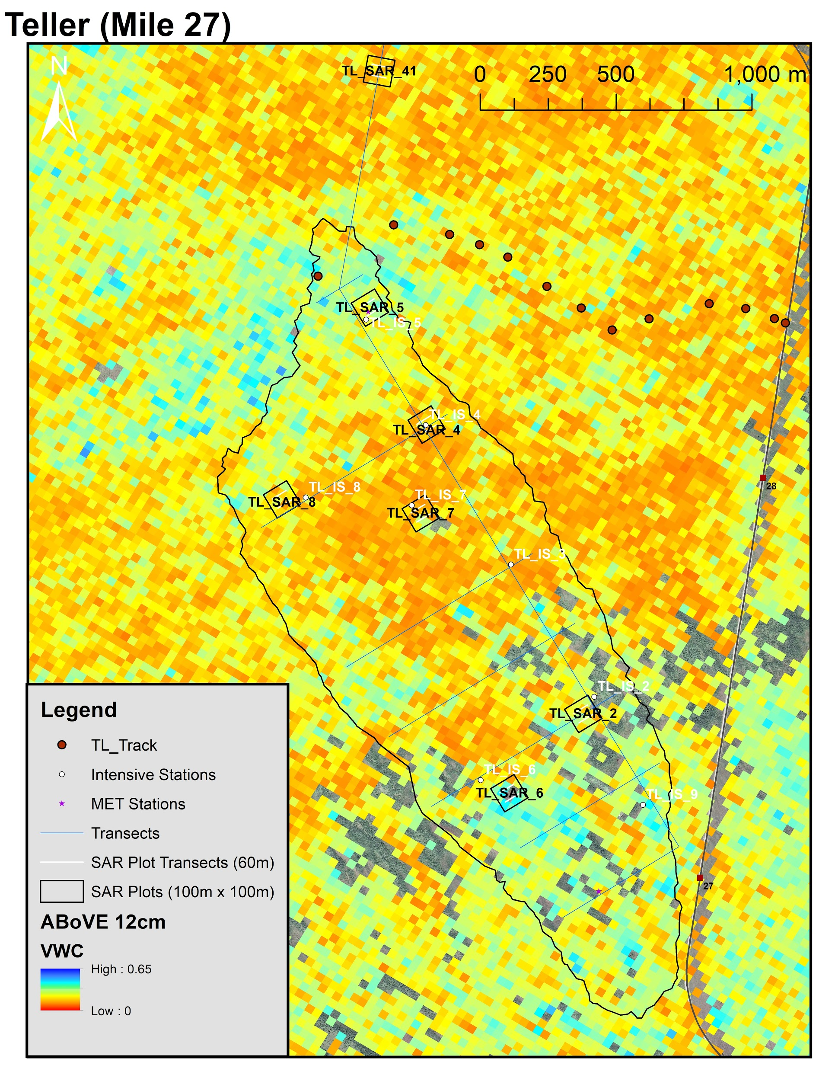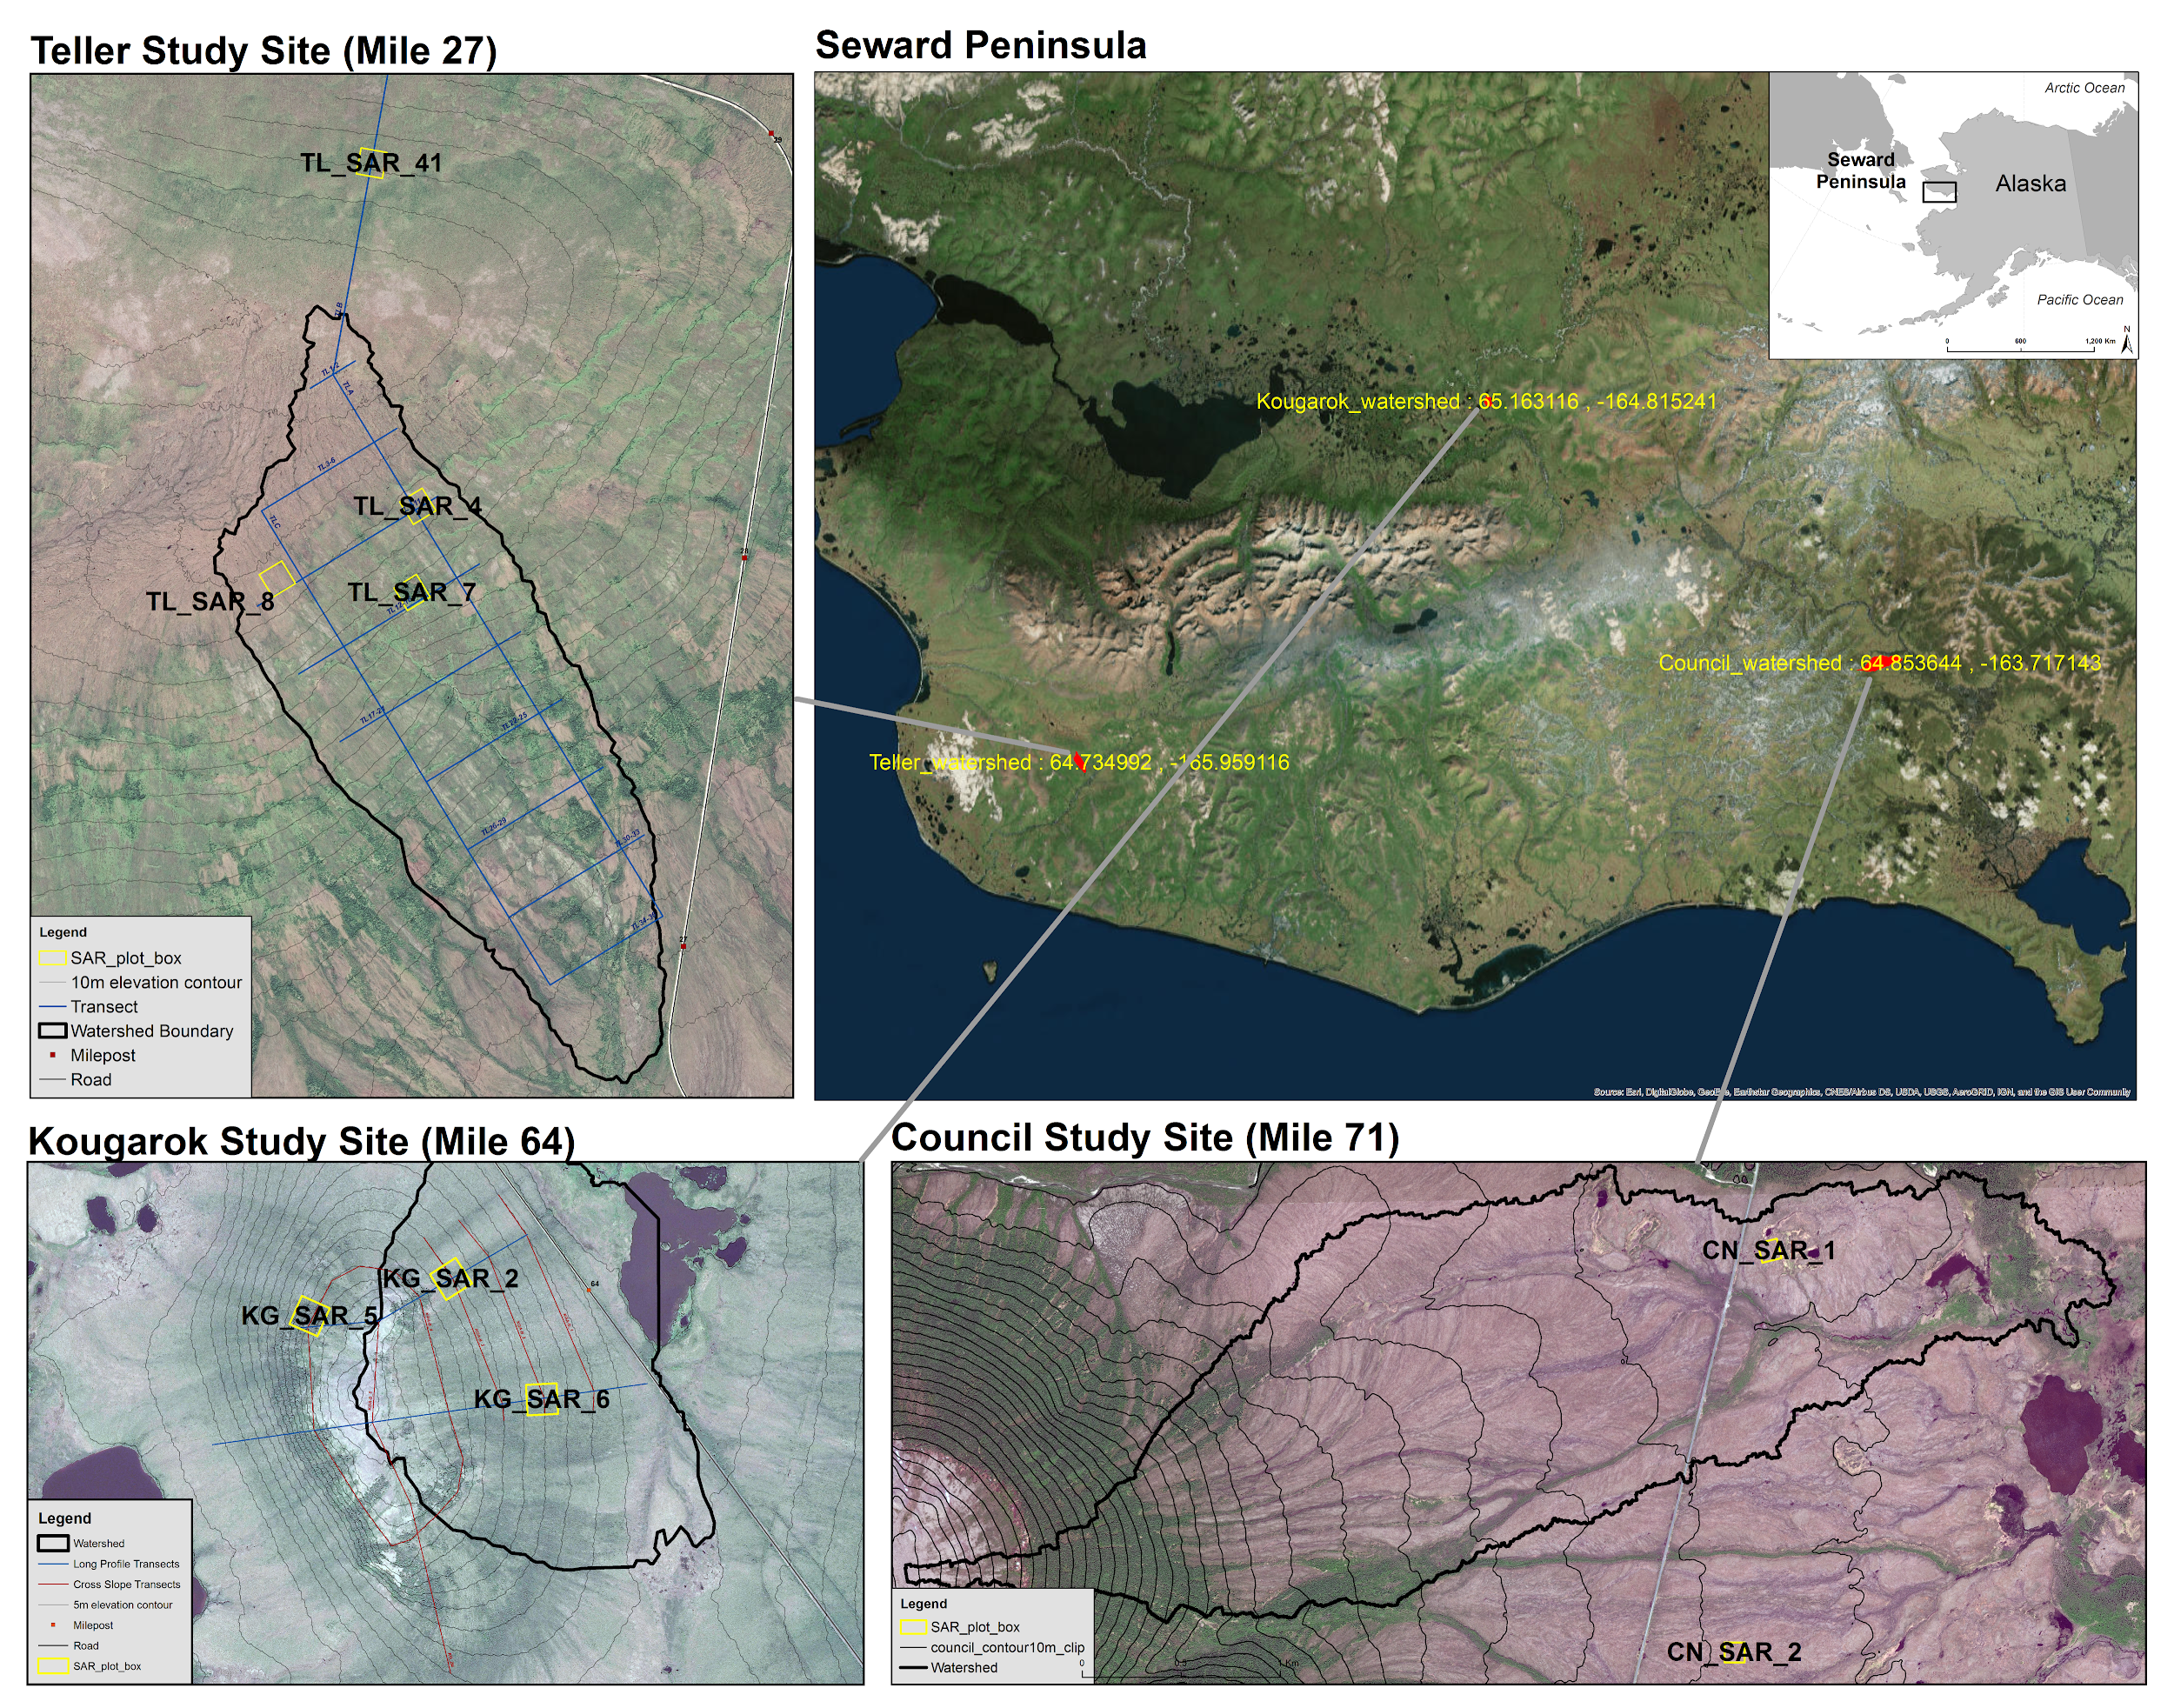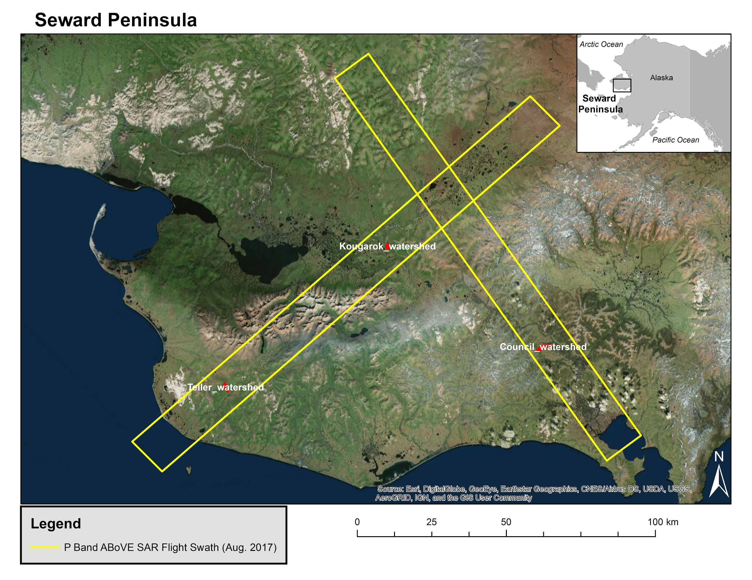

**2.** **Methods:**

a. Data collection with Hydrosense II

The in-situ soil moisture and thaw depth measurements provided in this paper were collected coincident with airborne overflights of L- and P-band SAR instruments at the NGEE Arctic study site near Barrow, on the North Slope, and at the three study sites on the Seward Peninsula, Alaska. Field measurements and flights were conducted during the summer of 2017 as a collaboration between the NASA ABoVE Project’s Airborne SAR Campaign and the NGEE Arctic Project.

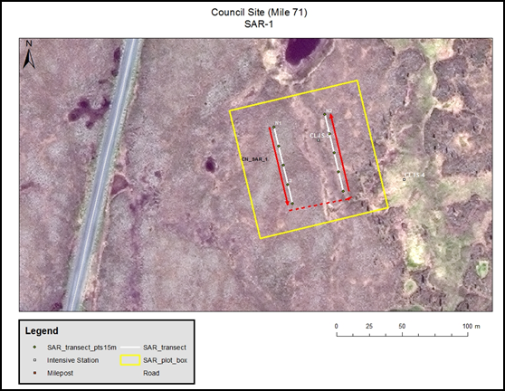

**Figure 1.** SAR Plot 1 at the Council Site on the Seward Peninsula. Plot is 100 x 100 m with two 60-m transects and showing flag locations for soil moisture measurements along each transect. The red lines indicate where thaw depth was measured.

ABoVE protocols for establishing field measurement plots were followed. The optimum plot size for SAR studies is one hectare or 100 x 100 m. This size will produce enough ground area for averaging of multiple pixels for both airborne and spaceborne SAR data. The first step in setting up a field plot was to identify a one-hectare area that has a relatively homogeneous vegetation cover. Because ground conditions in Arctic ecosystems are highly variable at meter to sub-meter scales, it is necessary to employ a sampling scheme that captures this smaller scale variability. Two 60-m long sample transects were established, as outlined in Figure 1, to systematically sample the site for soil moisture, thaw depth, and organic layer thickness in each plot.

NGEE Arctic plots for the ground-based measurements are located at existing study sites where SAR data would also add value to current monitoring and characterization efforts of the NGEE Team. Plot locations were chosen by their proximity to intensive sites, spatial separation, and vegetation type diversity.

· At Barrow, 3 plots were established and sampled in June and September, 2017. See Appendix Figure 1.

· On the Seward Peninsula, 2 plots were established and sampled at Council, 4 at Teller, and 3 at Kougarok during May and August, 2017. See Appendix Figures 2, 3, and 4.

· Twelve “SAR plots” total.

Soil Moisture

A Hydrosense II probe and data logger (with GPS) were used to measure soil moisture properties.

Along each 60-meter transect, 3 sampling spots were flagged every 15 meters for soil moisture parameter collection. Fifteen measurements were collected in a semi-circle at each sampling spot (90 per plot), that is five at 6 cm (60 degree angle), five at 12 cm, and five at 20 cm depths.

Thaw Depth

Using the two 60 m transects, thaw depth measurements were collected using a frost probe every 5 m along each transect, beginning at 0 m, which resulted in 13 samples per transect and 26 per plot. Surface conditions and any obstacles encountered while probing that would influence the measurement were noted.

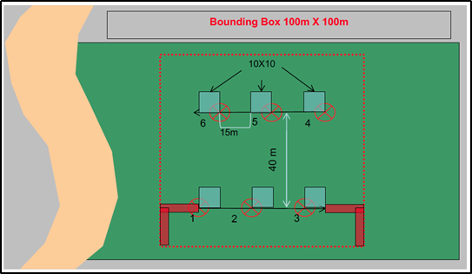

**Figure 2.** Plot sampling scheme. For soil moisture, three sampling points were established along each 60-m transect (red circles). Thaw depth was measured every 5 m (starting at 0) along both transects.

**Volumetric Water Content**

Volumetric water content data were collected using a Hydrosense II soil-water sensor and data logger which collected the GPS location of the moisture samples. Hydrosense sensor rely on soil dielectric properties to estimate volumetric water content (VWC). Each SAR plot consisted of two 60 meter transects with 3 flags for soil field parameter collection.

The moisture measurements were taken at flags located at 15, 30, and 45 meters along each transects. At each flag 15 measurement were collected from 5 approximately collocated locations as showing in Figure 2: five at 6 cm, five at 12 cm and five at 20 cm.

The 6 cm samples were collected by inserting the vertical 12cm probe at a 60-degree angle to the horizon and for the 12 and 20 cm samples, the 12 and 20 cm probes, respectively, were inserted vertically, Figure 4. A total of 90 moisture measurements were taken at each SAR plot as long as there were no rocks, snow or the ground was frozen.

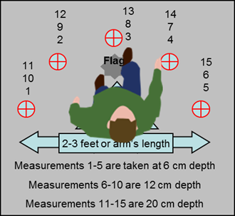

**Figure 3.** Example of how the moisture measurements were taken at each flag.

**Figure 4.** A diagram of how the Hydrosense II probes were inserted to collect data at varying depths.

b. ABoVE SAR data collection

c. Chen et al. 2018 procedure to get VWC/dielectric constant profiles

d. Calibration procedure of the in-situ data

# **Hydrosense Soil-Water Sensor Calibrations**

# 

Calibrations to Hydrosense II data taken between June and September at Barrow and Seward sites are based on the general algorithm specified by the ABoVE Project’s, Laura Bourgeau-Chavez (lchavez@mtu.edu).

After going through soil classifications as specified and performing the calculations, we were still getting numbers that did not make sense. After discussion, Laura came to the conclusion that our soil must have been significantly different from their lab soil and that we should use the coefficients specified below. Laura and her lab techs did not measure 6 cm with the Hydrosense II (our instrument), she advised us to use the 12-cm coefficients for the 6-cm measurements.

|  |  |  |  |  |  |  |  |
| --- | --- | --- | --- | --- | --- | --- | --- |
| **Group** | **Probe** | **Probe Depth** | **A** | **B** | **C** | **R2** | **Standard Error** |
| General | HydroSense II | 20 cm | 7.693 | 1.641 | -12.341 | 0.8873 | 5.773 |
| General | HydroSense II | 12 cm | -24.28 | 134.55 | -110.245 | 0.8294 | 7.102 |
| General | HydroSense II | 10 cm | -5.307 | 58.327 | -64.615 | 0.7621 | 8.388 |

**Calculation of VWC using Hydrosense II Calibration Coefficients**

Where θ is the volumetric water content (% VWC), τ is the period in microseconds, and A, B, C are coefficients from the table above that are based on lab measurements of soils.

For more information refer to the NASA_ABOVE_CalibrationSummary_20171115.pdf companion file and:

Bourgeau-Chavez, L., Garwood, G. C., Riordan, K., Koziol, B. W., & Slawski, J. (2010). Calibration algorithm development for selected water content reflectometers to organic soils of Alaska. International Journal of Wildland Fire, 19(7), 961-975.<http://dx.doi.org/10.1071/WF07175>

The provided VWC data were derived with these coefficients.

**3.** **Analysis:**

1. **Weather conditions around the time of flight on the Seward peninsula.**
   1. Using the meteorological stations available at the Teller and Kougarok fieldsites, we can better understand the time period observed by our in-situ and airborne measurements. From this we see that the measurements are taken in the middle of it starting to get colder again. We also see a considerable rain event that took place between August 10th and 12th, which is roughly a week before measurements were taken.

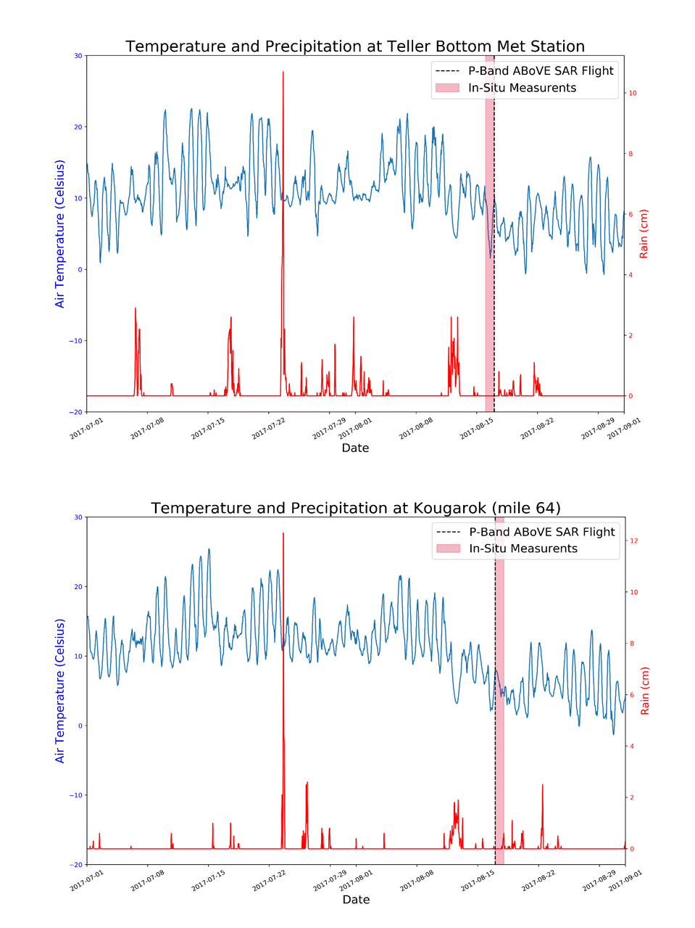

1. GAP/LANDFIRE LandCover classifications
   1. I looked at 30mx30m classifications of the tundra landscape from imagery in 2001 to look at impact on SAR results. (<https://www.usgs.gov/core-science-systems/science-analytics-and-synthesis/gap/science/land-cover-data-overview?qt-science_center_objects=0#qt-science_center_objects> )
      1. Compare surface roughness (h) from Richard Chen with land cover classification for 2017 august flight
      2. Method: Made landcover into integer raster. Use with zonal statistics and export as table
         1. R. Chen et al 2018 defines roughness as (root-mean-square (rms)) height (h) and correlation length L_c



* + 1. **Compare surface roughness with various DEMs**
       1. **Terrain Roughness Index of DEMs**
    2. Site Classifications
       1. Teller
          1. 57.9% Alaska Arctic Birch-Ericaceous Shrubland
          2. 17.5% Alaska Arctic Mesic-Wet Willow Shrubland
          3. 8.6% Alaska Arctic Shrub Tussock Tundra
       2. Kougarok
          1. 37.9% Alaska Arctic Shrub Tussock Tundra
          2. 10.1% Alaska Arctic Mesic-Wet Willow Shrubland
          3. 10.1% Alaska Arctic Tussock Tundra
       3. Council
          1. 20.5% Alaska Arctic Mesic-Wet Willow Shrubland
          2. 17.3% Alaska Arctic Shrub Tussock Tundra
          3. 15.3% Alaska Arctic Wet Sedge Meadow
  1. Look at ALT vs. Landcover type.

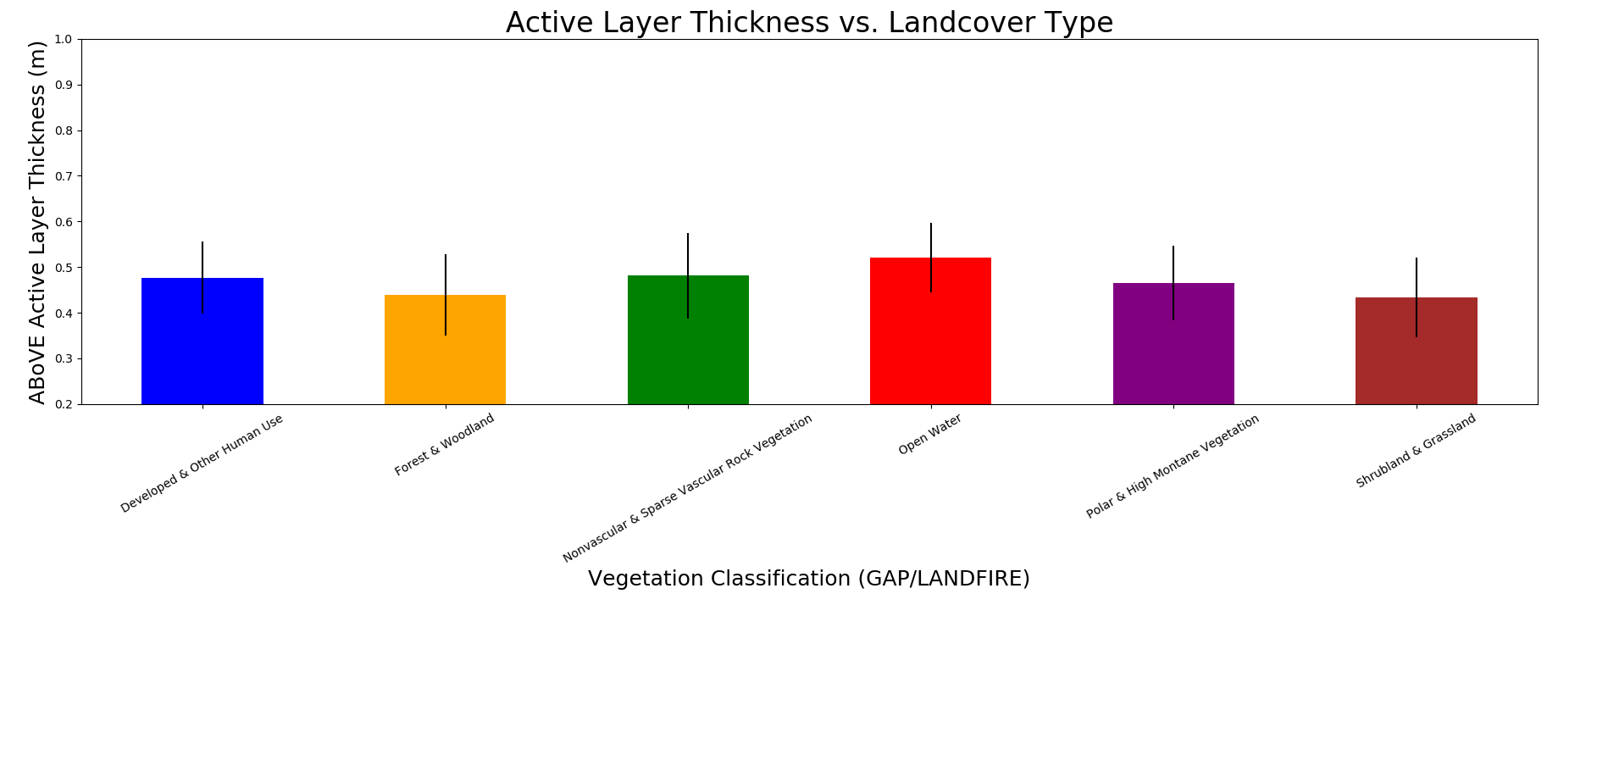

**Use NoVA statistics on this (ask emma)**

1. **Look at NLCD in comparison with h/alt to compare with figure 19**
2. Comparing soil moisture models
   1. Engstrom Model (2005)
      1. ABoVE vs. Hydrosense

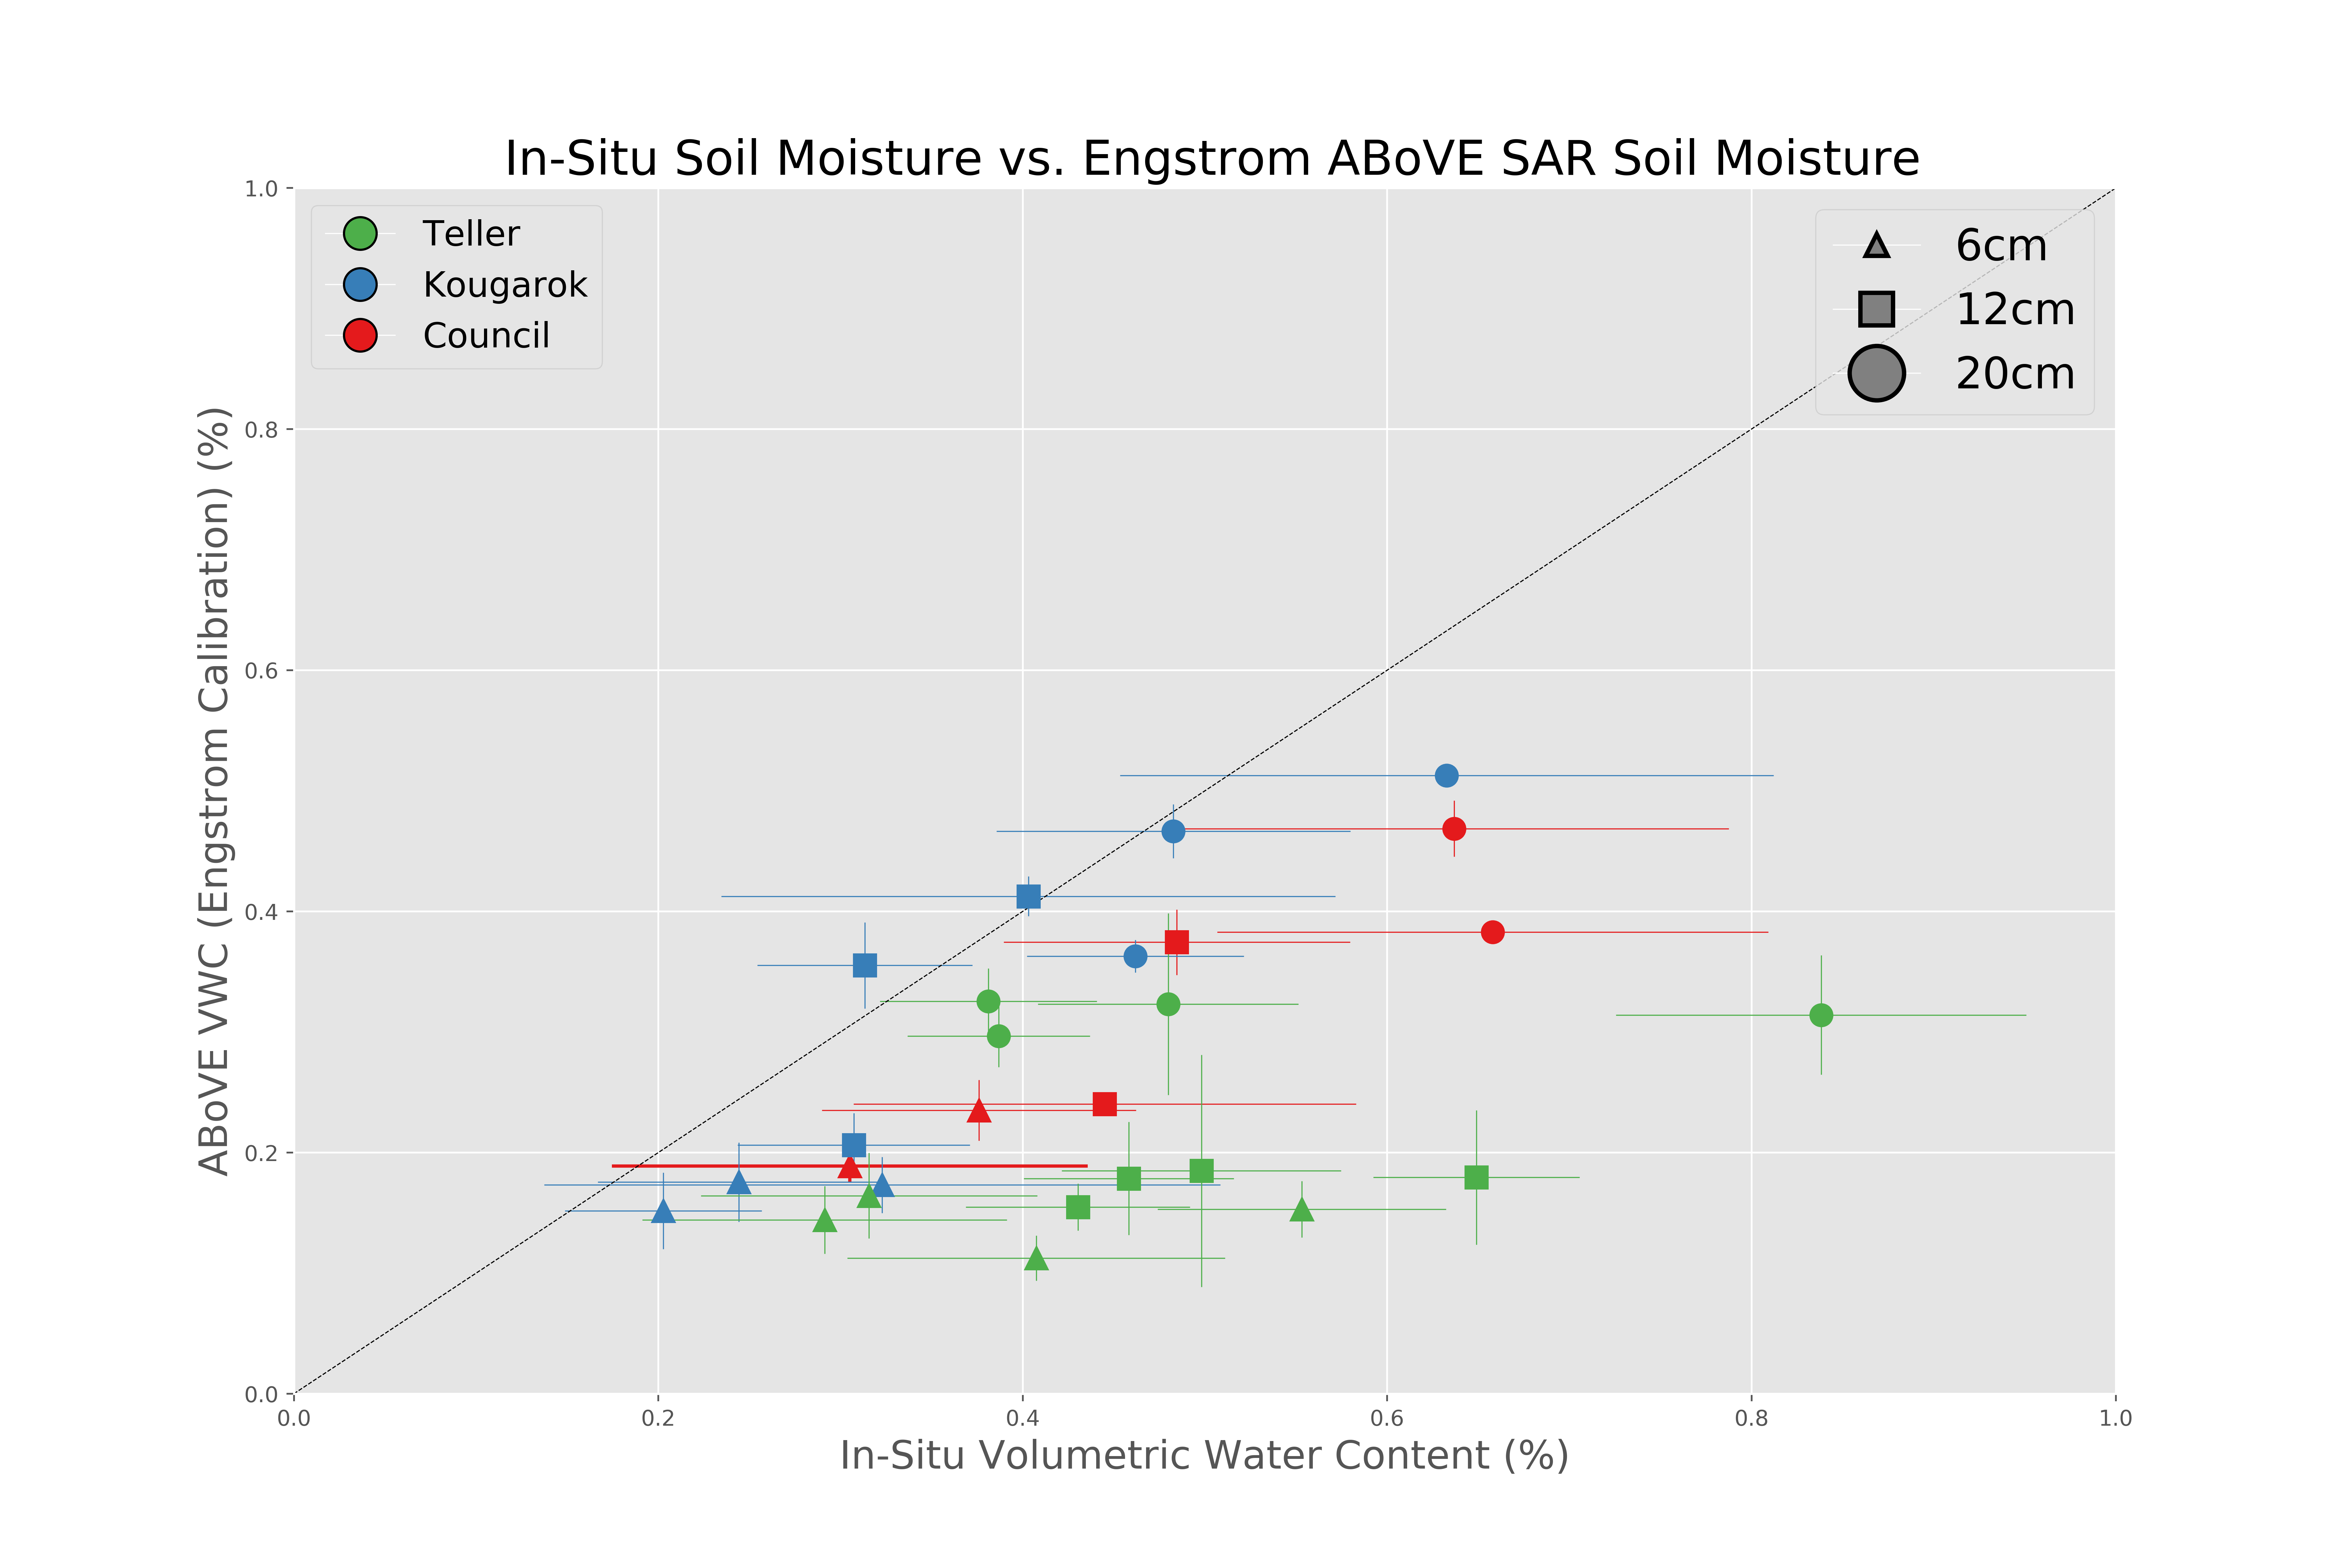

* 1. Laura B.C. (2010)
     1. ABoVE (calibrated) vs. Hydrosense with same calibration

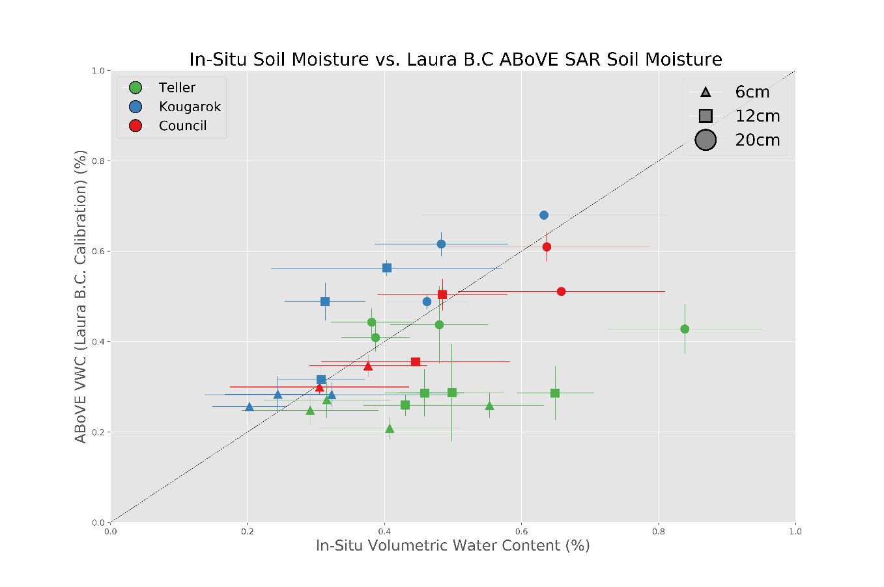

**Why is Teller such an outlier? (weather?) Make separate r squared values for each site and justify why the topography might make sense for that.**

* 1. Soil Sample vs. Hydrosense (Emma)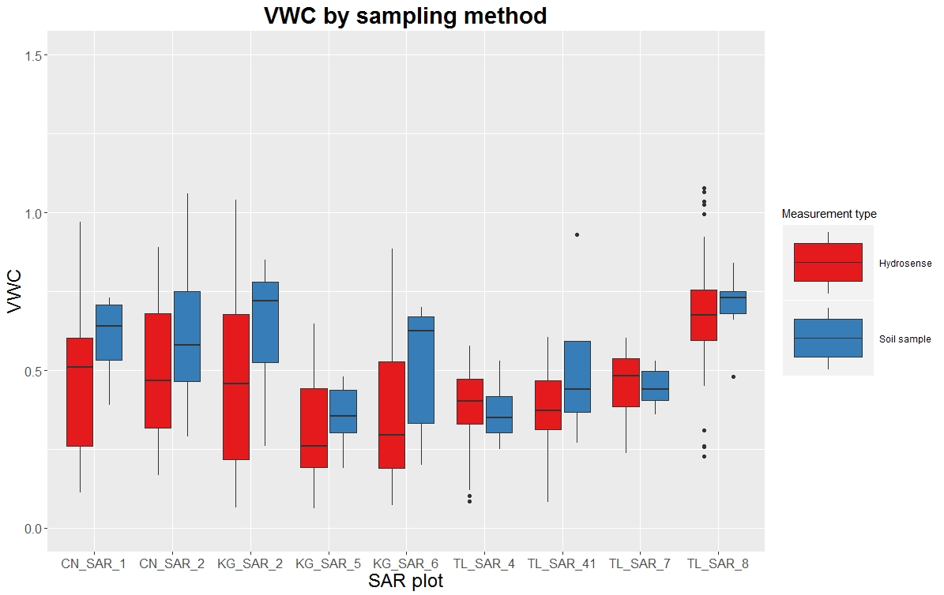

1. In-situ ALT vs. Bird in the sky ALT
   1. This plot shows the average in-situ thaw depth value, within each ABoVE pixel, recorded by NGEE scientists in the field. As is evident the current ABoVE algorithms used for the Seward peninsula do not show a correlation between the two values.

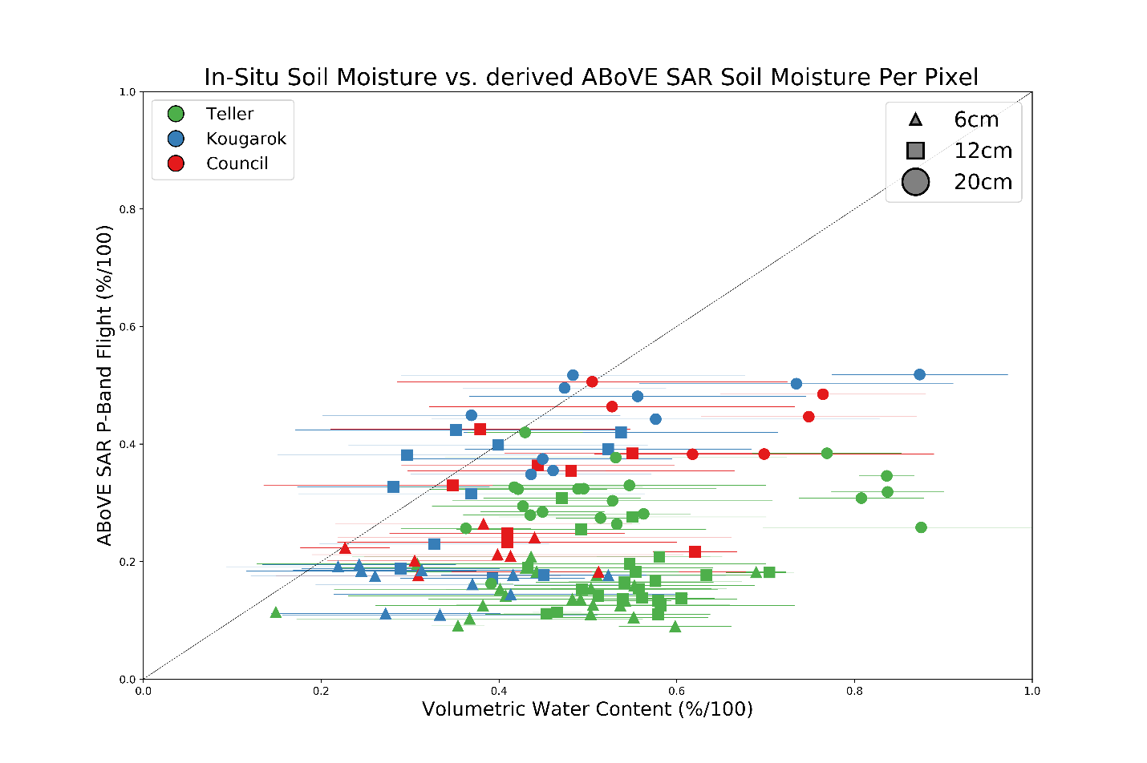

LBC Method: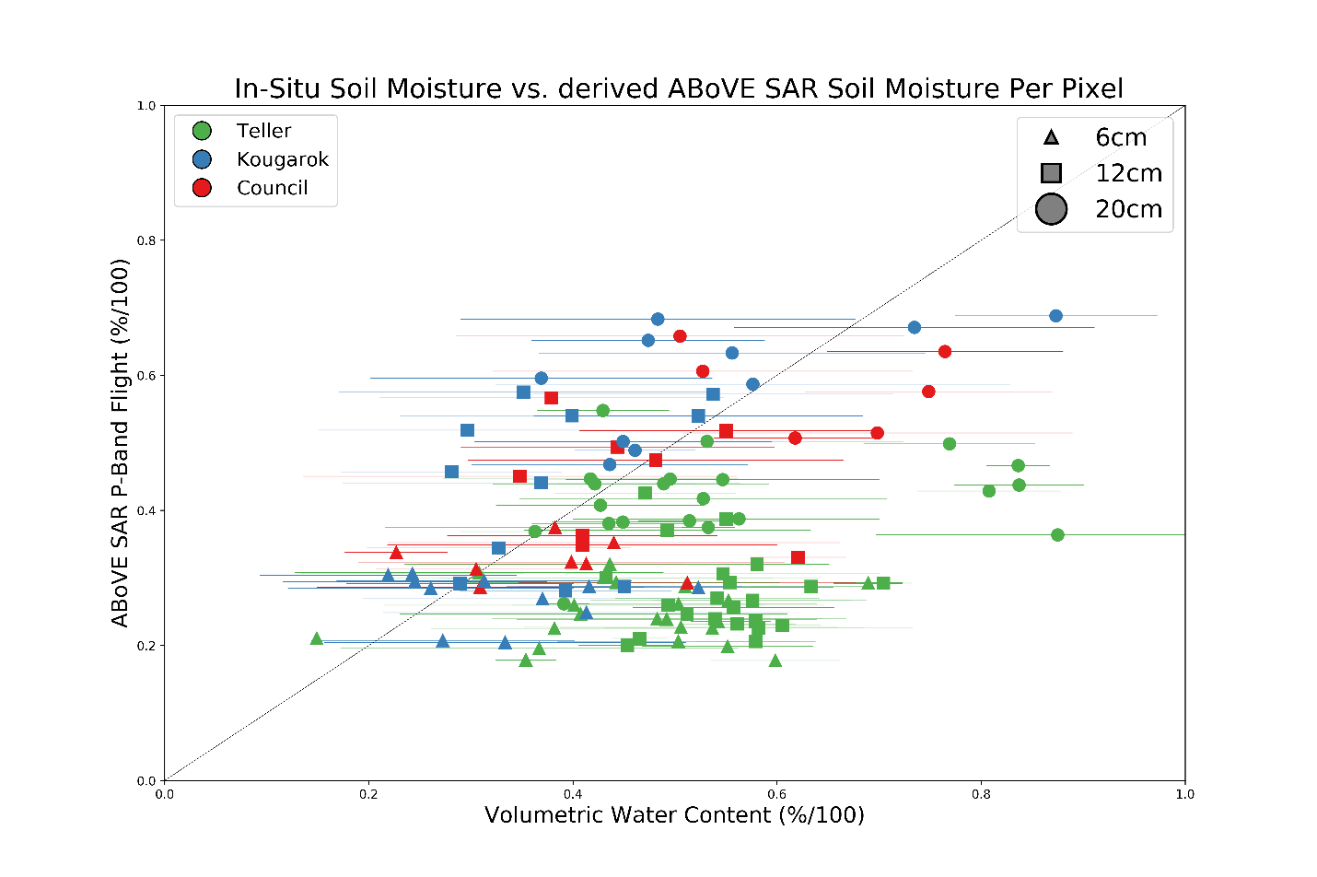

* 1. Individual R^2 tests to look for any solid trends. If this shows anything, it shows that there are no trends in this amount of data. This is per pixel averaged VWC

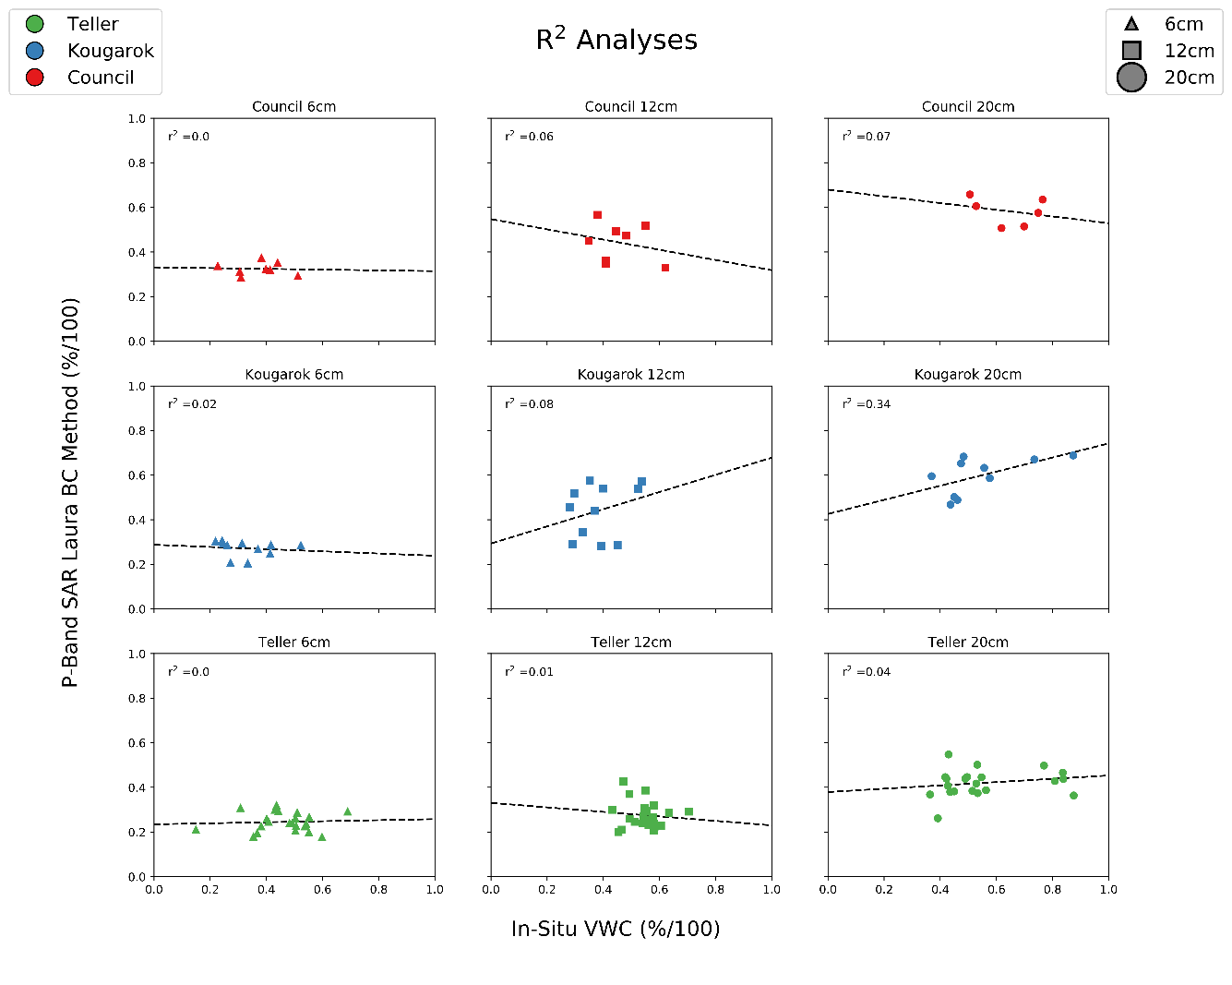

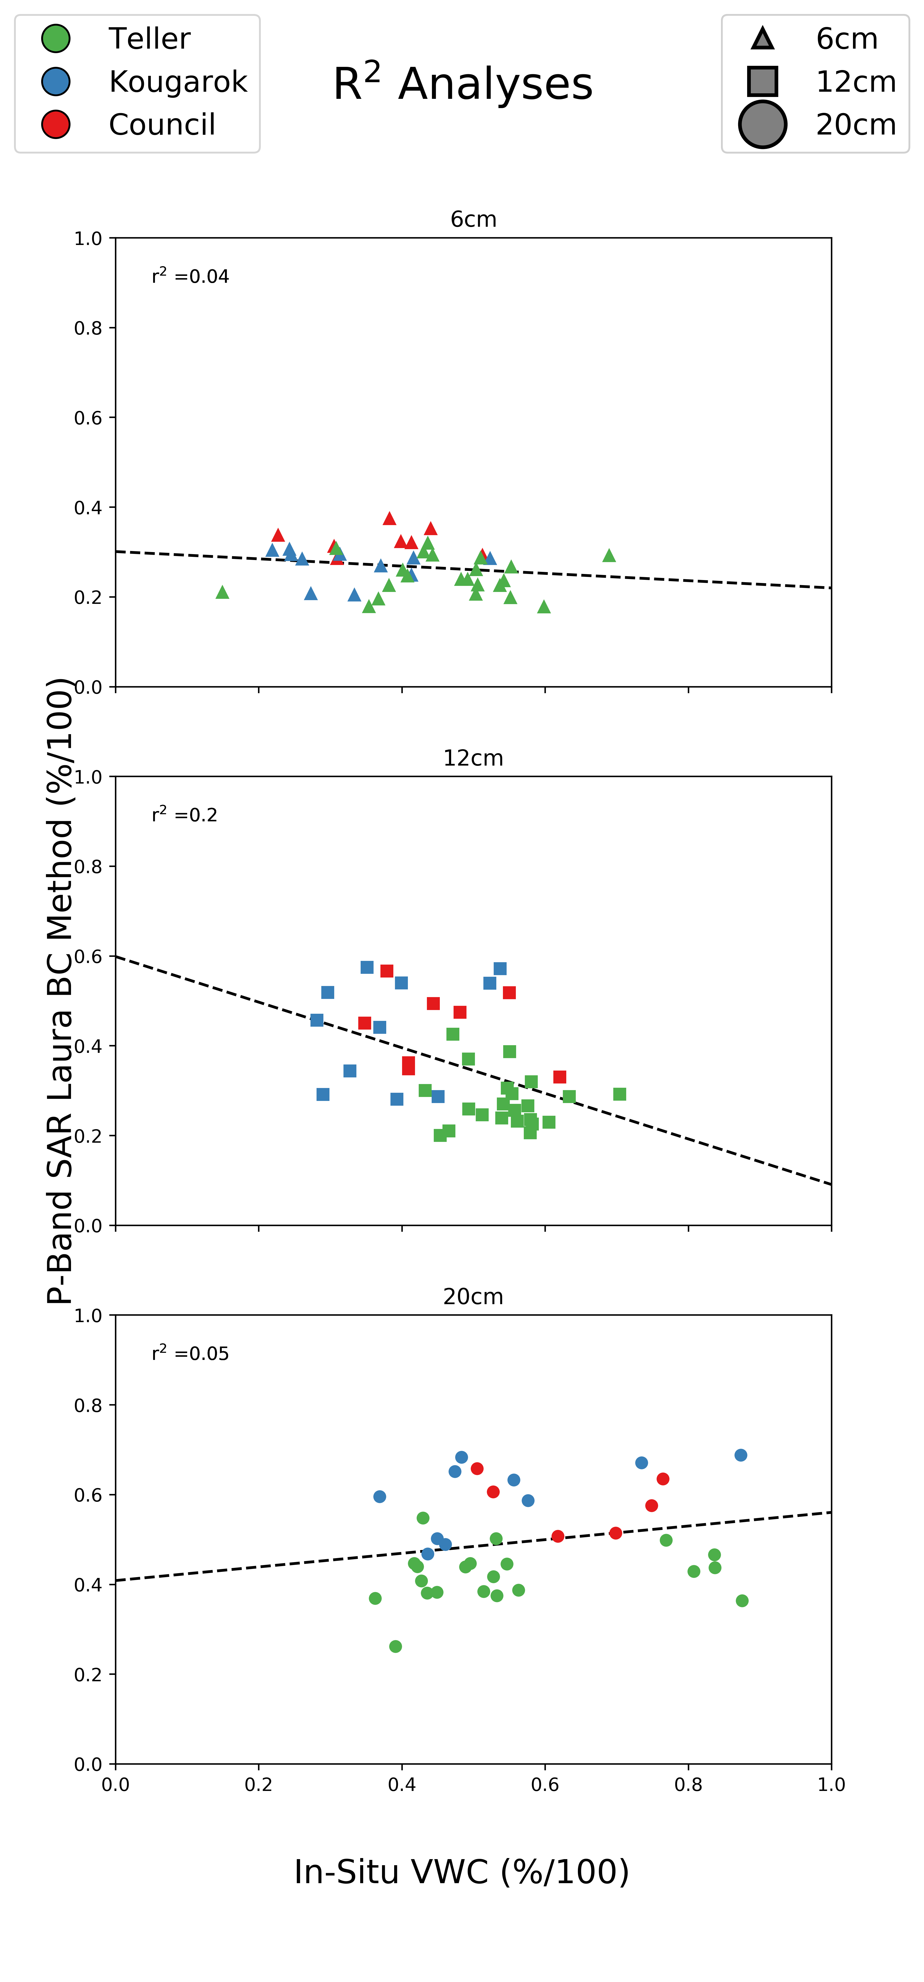

**Throw out teller?**

* 1. Based on depth only

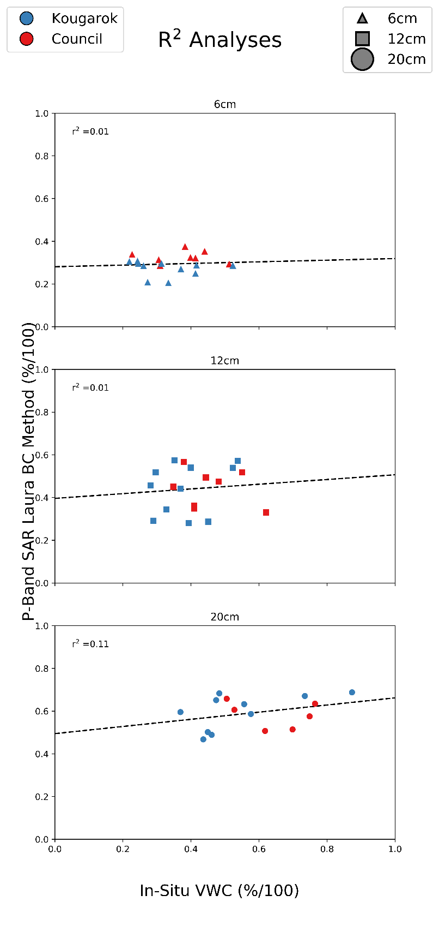

* 1. Look at chi^2 statistic in equation 10 to understand whether there is a positive correlation. (radar sensing depth)

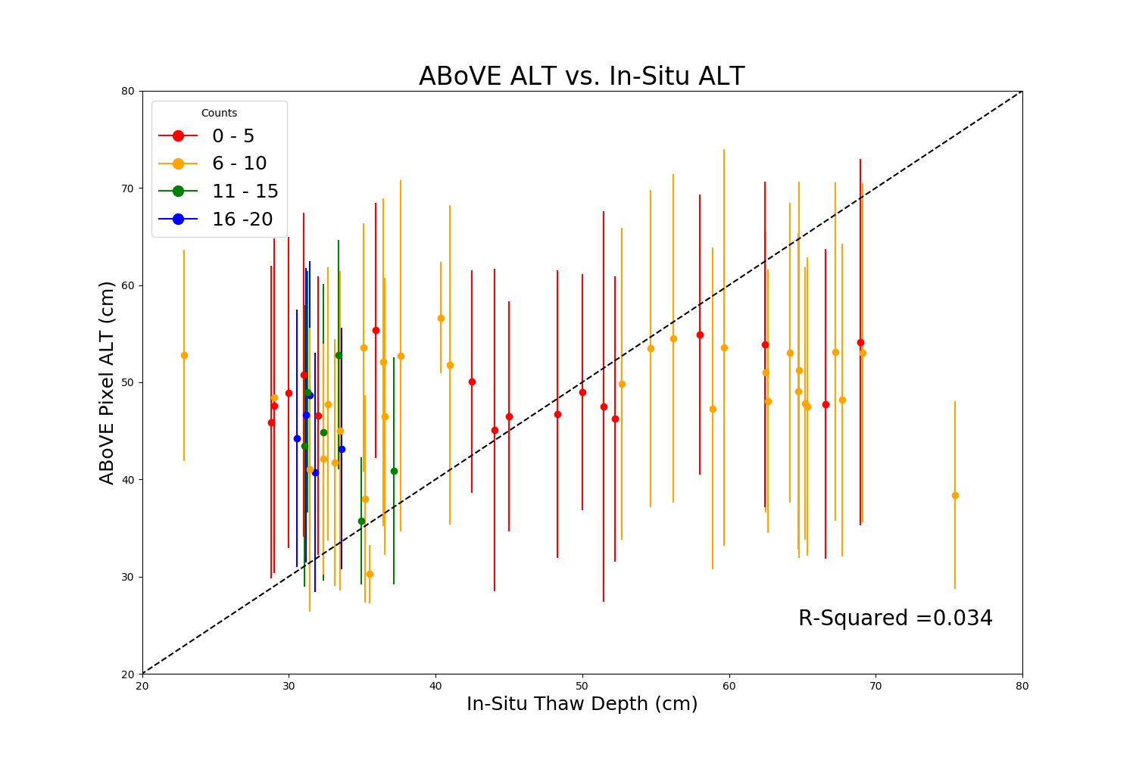

1. Aspect
   1. Sun Factor (equation 4 in Min’s paper)
2. Slope

**4.** **Conclusions:**